Reginald Dubé
Prof Miranda
CIST 2612: Computer Forensics
12 March 2026
Kali Linux Digital Forensics Environment Setup and Tool Identification
This project will focus on installing Kali Linux as we explore the world of Digital Forensics tools that are used to collect, analyze, and manage digital evidence. This project will also help develop very important skills in Cyber Security you’ll need to be successful with handling evidence as well as investigations.
Kali Linux Installation Plan
Kali Linux will be installed on my MacBook Pro using VirtualBox. This allows full control of the system from a local position. Performance will be faster and the ability to practice forensic investigations without the need of internet access or cloud cost.
Pre-Installation Steps
Before I install, I will make sure my computer has at a minimum 8-40GB of space. I will download VirtualBox and Kali Linux ISO file. Make sure the correct version for IOS latest version of Apple Silicone.
Post-Installation Configuration
After the installation I will make sure systems are up to date. Network connectivity will be tested, and forensic tools functionality will be verified.
Forensic Tools Identification
Several forensic tools will be used including Autopsy for disk analysis, Volatility for memory analysis, Wireshark for network traffic inspection and Stegsolve for steganography detection.
Categories:
Disk Imaging – FTK Imager/Encase Forensic: Preserve evidence integrity. Create forensic copies for analysis. These tools are used to create exact copies (bit by bit) of storage without altering the original evidence.

Live Acquisition – Dumpit/Belkasoft live RAM Capturer: Capture RAM contents. Retrieve encryption keys, running processes, network connections. These tools are used collect volatile data from a system that is still running.

Memory Analysis – Volatility/Rekall: Detects malware in memory. Identify hidden processes and injected codes. These tools are used to analyze RAM dumps to uncover hidden or malicious activity.

Network Analysis – Wireshark/tcpdump: Monitor suspicious traffic. Detect intrusions and data exfiltration. These tools are used to capture and analyze network traffic.

Malware Analysis – Cuckoo Sandbox/IDA Pro: Understand malware behavior. Identify indicators of compromise (IOC’s). Thes tools are used analyze malicious software behavior and structure.
Stenography – Stegsolve/Stegdetect: Reveal hidden messages or files. Investigate covert communication. These tools are used to detect hidden data with images, audio. Or files.
Evidence Acquisition Strategy
Evidence will be acquired by using imaging tools while maintaining integrity through hashing as well as proper documentation procedures. To acquire and manage digital evidence, I would follow a structured forensic process by using tools that are specialized across several categories. The FTK Imager or dd would be used to create a bit-by-bit forensic image of the target storage device. This solidifies that the original evidence remains untouched through the analysis process.
If the system is powered on, I’d perform live acquisition using tools like Dumpit to collect volatile data such as RAM, running processes, and active network connections. This is a critical step because volatile data can be lost if the system is shut down.
Next, I would take the captured memory and analyze it using Volatility to identify suspicious processes, hidden malware, or evidence of compromise. For network related evidence, I’d use Wireshark to review traffic and detect anomalies or unauthorized communications. If malware is suspected I would utilize sandboxing and reverse engineering tools like Cuckoo Sandbox to safely observe behavior and extract indicators of compromise. Then I would employ steganography to uncover hidden data files with tools like Stegsolve.
Best Practices
In conducting digital forensics, I will strictly adhere to the industry best practices to ensure evidence is reliable and admissible.
Maintain Chain of Custody:
Every piece of evidence will be documented from the moment it is collected, including who handled it, when, and why.
Ensure Data Integrity:
Hash values will be generated before and after acquisition to verify that evidence has not been altered.
Use Forensically sound methods:
modifications of original data.
Document Everything:
Detailed notes will be kept on procedures, tools used, timestamps, and findings to support reproducibility and legal scrutiny.
Work from Copies only:
Analysis will always be conducted on forensic images, never on original evidence.

Conclusion
This project will prepare a functional forensic lab environment develop practical investigative skills. I am fully prepared to proceed with this project using a structured and methodical approach to digital forensics. By leveraging industry-standard tools and adhering to established best practices, I will ensure that all evidence is properly acquired, preserved, and analyzed. This approach not only maintains the integrity of the investigation but also ensures that findings are credible, defensible, and aligned with professional forensic standards.

Part 2: Kali Linux Installation. Successful installation on a local MacBook pro M1 chip using VirtualBox.
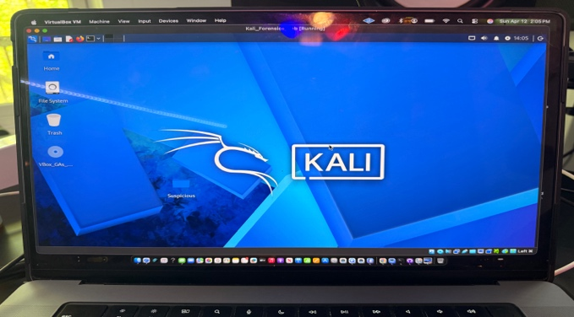
The suspicious folder in Kali.
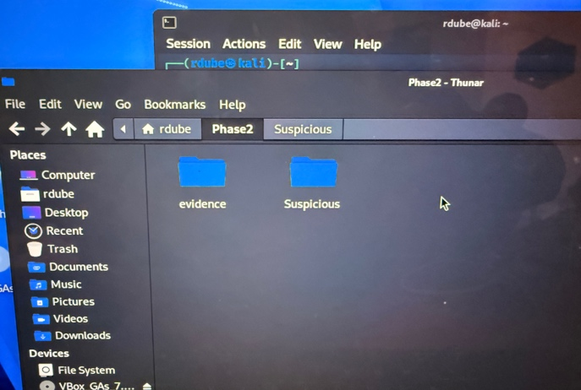

List Block Devices (lsblk). Used to identify the target disk. The primary disk /dev/sda (40GB) was selected for imaging. The disk contains two partitions including the root partition mounted at /.
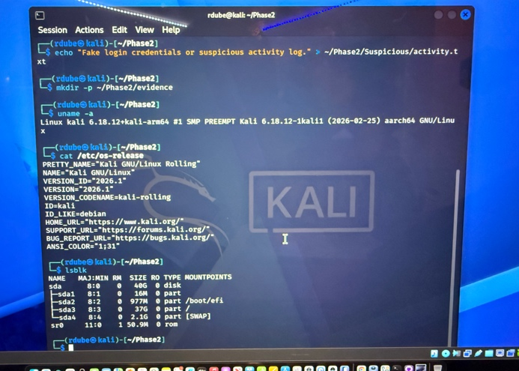
The dc3dd command tool was used to acquire a bit-for-bit image of the target disk. The command included SHA256 hashing to ensure data integrity.
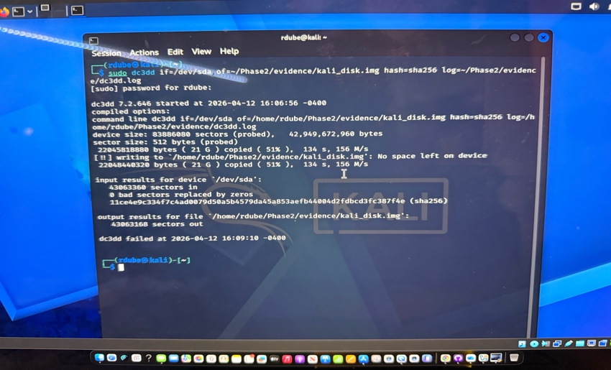
The SHA256 hash output.
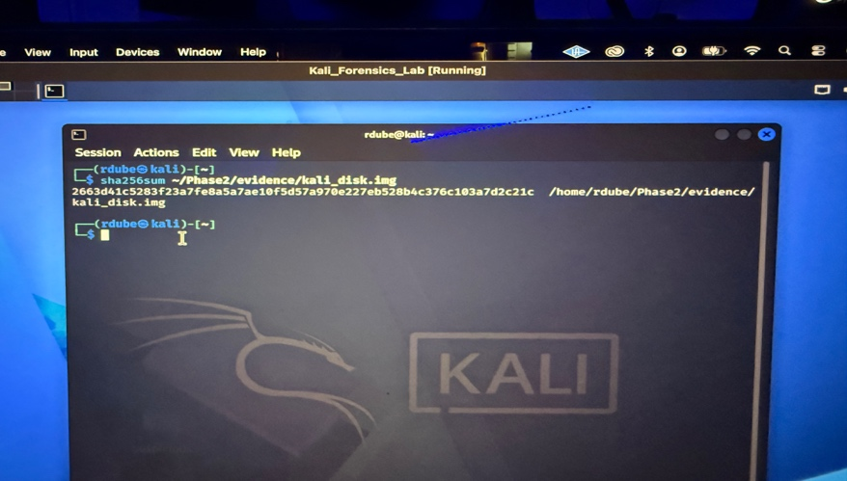
Wireshark
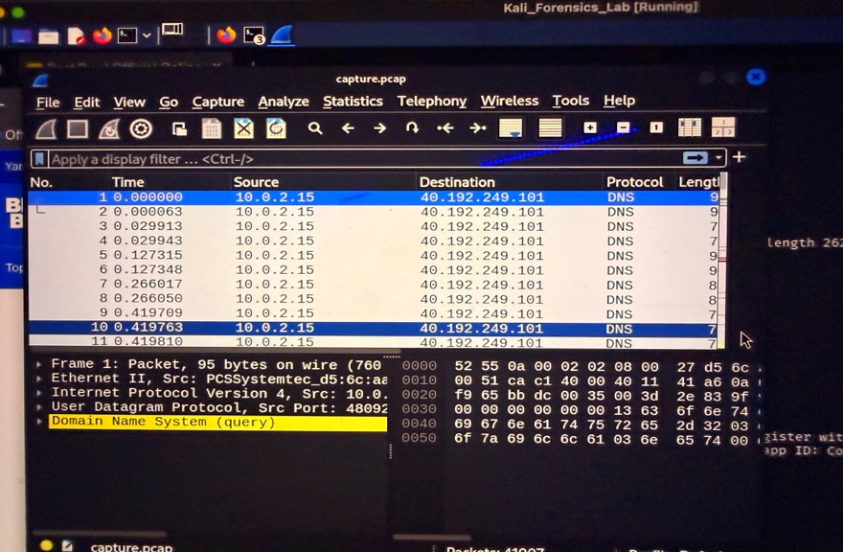
Evidence folder contents
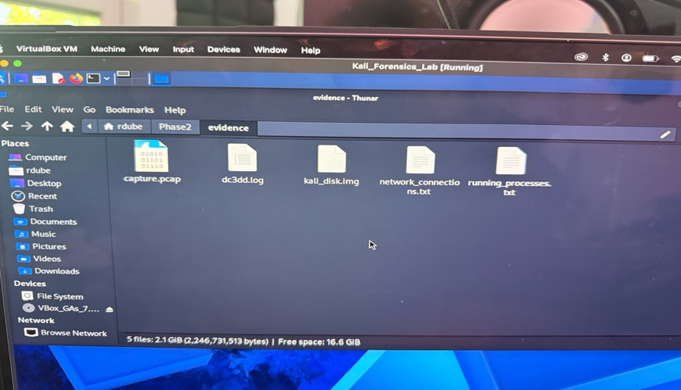
Tcpdump
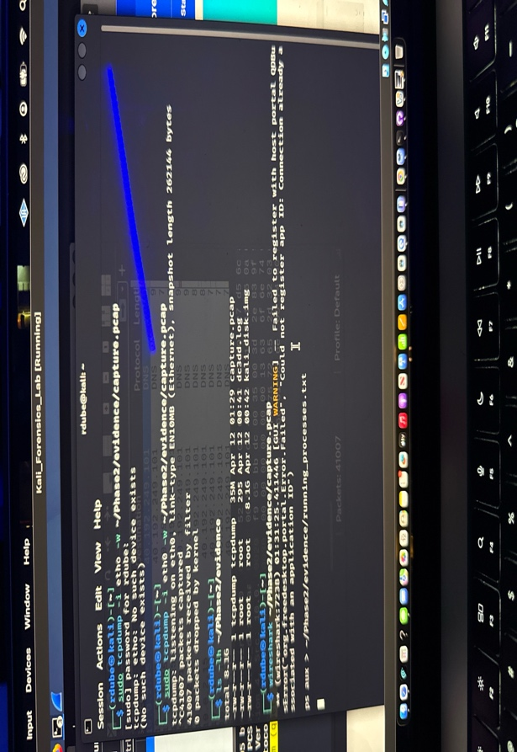
Ip -a
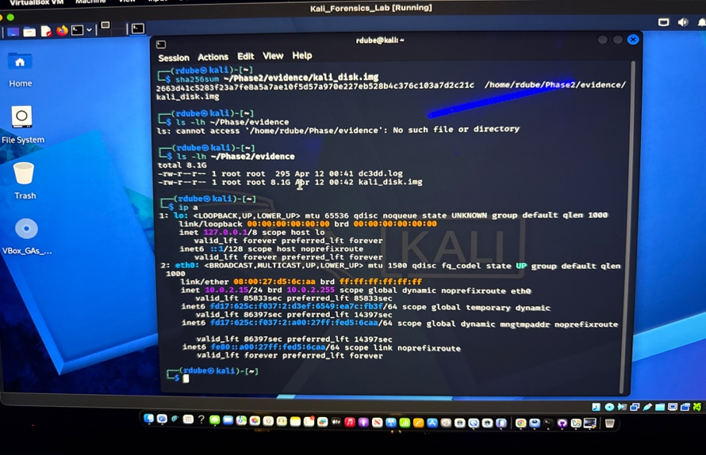

Forensic Acquisition Report – Phase 2

A. Target System Description
The target system selected for this forensic acquisition project was a local virtual machine running Kali Linux within VirtualBox.
- Platform: Local Virtual Machine (VirtualBox)
- Operating System: Kali Linux
- Purpose: To create a controlled forensic environment for data acquisition
- Simulated Incident:
A directory named “Suspicious” was created to simulate potential malicious activity. This directory contained the following files:
- note.txt
- activity.txt
- unknown.exe
These files represent potential indicators of compromise that would be analyzed during a forensic investigation.

B. Acquisition Plan
The following acquisition methods were performed:
- Disk Imaging
- Network Traffic Capture
These methods were selected to capture both static evidence (disk data) and dynamic evidence (network activity).
Tools Used:
- dc3dd (disk imaging)
- tcpdump (network capture)
- Wireshark (packet analysis)
Justification:
The dc3dd tool was selected because it creates a bit-for-bit forensic image while generating a SHA256 hash to ensure integrity. Tcpdump was used to capture live traffic, and Wireshark was used to analyze the captured packets.

C. Step-by-Step Acquisition Procedures

1. Disk Imaging
The lsblk command was used to identify the system’s primary disk. The disk /dev/sda (40GB) was selected for imaging.
The following command was executed:
sudo dc3dd if=/dev/sda of=~/Phase2/evidence/kali_disk.img hash=sha256 log=~/Phase2/evidence/dc3dd.log
This process created a bit-for-bit forensic image of the disk while generating a SHA256 hash to ensure data integrity.
The hash was verified using:
sha256sum ~/Phase2/evidence/kali_disk.img
Hash Value:
198dddc1b5690fad443d4ec84f6b10a744deaba99a03947bf20e86af310db85e
The disk image was successfully stored in the evidence directory.

2. Network Traffic Capture
The network interface was identified using the ip a command.
The following command was used to capture network traffic:
sudo tcpdump -i eth0 -w ~/Phase2/evidence/capture.pcap
While tcpdump was running, network activity was generated by browsing websites and sending network requests.
The capture was stopped using Ctrl + C, and the resulting PCAP file was analyzed using Wireshark:
wireshark ~/Phase2/evidence/capture.pcap
The captured traffic included HTTP/HTTPS requests and DNS queries, demonstrating active network communication.

D. Challenges and Mitigation
Challenge | Mitigation
Identifying correct disk | Used lsblk to verify disk
Permission errors | Used sudo privileges
Network interface confusion | Verified using ip a
Large file sizes | Organized files in evidence folder

E. Chain of Custody Documentation
Evidence ID | Description | Hash | Date | Storage Location
E001 | Disk Image (kali_disk.img) | 198dddc1b5690fad443d4ec84f6b10a744deaba99a03947bf20e86af310db85e | April 12, 2026 | /home/rdube/Phase2/evidence
E002 | Network Capture (capture.pcap) | N/A | April 12, 2026 | /home/rdube/Phase2/evidence

All evidence was collected and stored in a secure location while maintaining forensic integrity.

F. Summary and Reflection
This phase successfully demonstrated the ability to perform forensic data acquisition in a controlled environment.
What worked well:
- Successful disk imaging using dc3dd
- Accurate SHA256 hash verification
- Effective network traffic capture using tcpdump
Areas for improvement:
- Further practice with memory acquisition tools
- Improved handling of large forensic image files
Preparation for Phase 3:
This phase establishes a strong foundation for forensic analysis. The acquired evidence is preserved, verified, and ready for deeper analysis in the next phase.

Evidence Storage Location
All evidence was stored in:
/home/rdube/Phase2/evidence

Evidence File Sizes
- Disk Image: 2.1 GB
- Network Capture: 35 MB
- Log File: 1.7 KB
- Running Processes File: 24 KB
- Network Connections File: 530 bytes

